**Practical 05**

**IP and Ping Utility**

**A. Find your private IP address**

1. [Open a command prompt](https://en.wikiversity.org/wiki/Command_Prompt/Open).
2. Type **ipconfig /all** and press Enter.
3. Observe the results.

|  |  |
| --- | --- |
| IP address | 192.168.50.241 |
| Subnet Mask | 255.255.255.0 |
| Default gateway | 192.168.50.1 |
| DNS Server | 192.168.50.1 |
| DHCP enabled? | Yes |

**B. Configure computer to use Static IP Address**

1. On the left end of the taskbar, right-click on ***Start Windows* icon, select Run. Type control panel and click OK.**

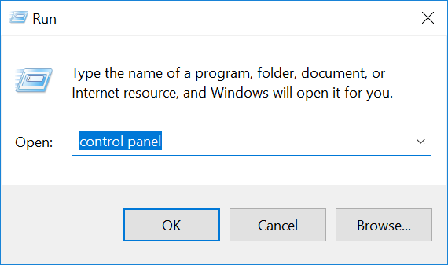

1. Click Network and Sharing Center.
2. Click Wi-Fi connections, then click Properties.

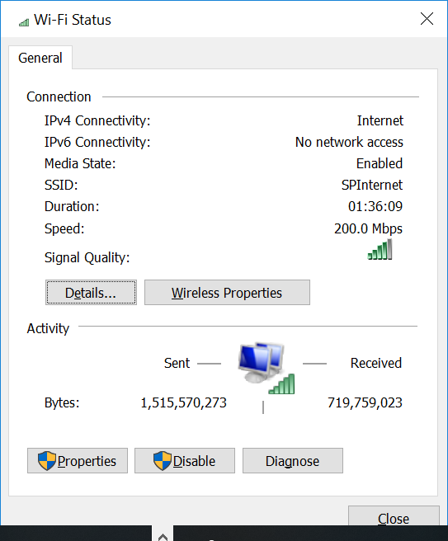

1. Select Internet Protocol Version 4, choose Properties.

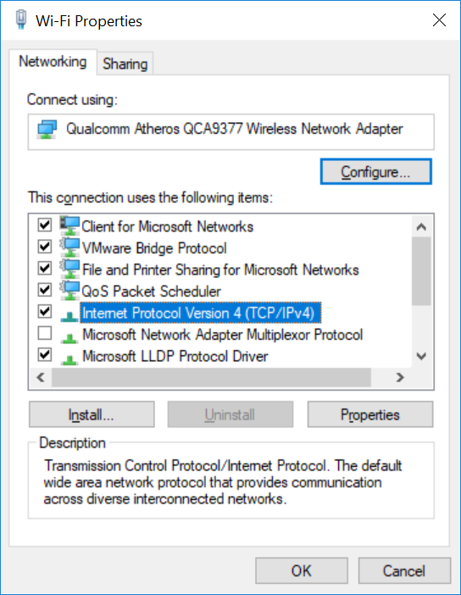

1. Select Use the following IP address.

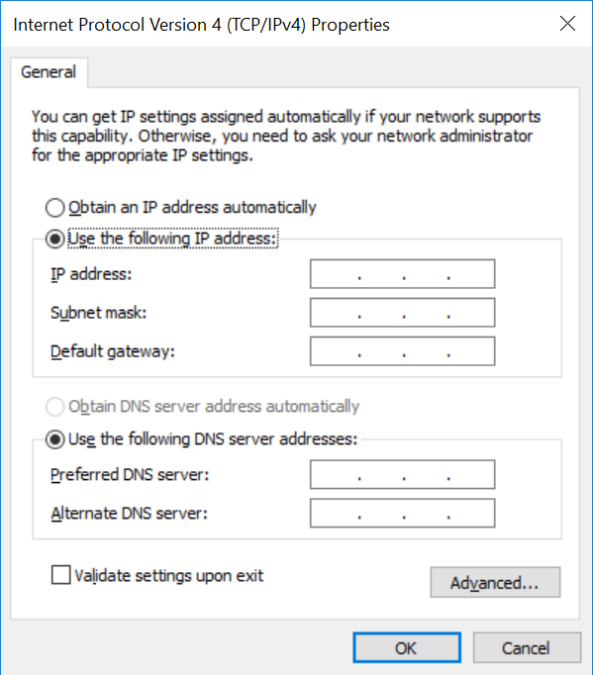

1. Key in the IP address, subnet mask and default gateway as recorded in task A step 3.
2. Type **ipconfig /all** in your command prompt, observe the changes:

|  |  |
| --- | --- |
| IP address | 192.168.50.241 |
| Subnet Mask | 255.255.255.0 |
| Default gateway | 192.168.50.1 |
| DHCP enabled? | No |

1. Type **ping google.com** in your command prompt to see if your configuration works. Does your configuration work? If no, what must be done (to make it work)?
2. Go back to restore your configuration to set DHCP enabled so that your computer will be able to obtain IP address automatically from [**DHCP**](https://en.wikipedia.org/wiki/Dynamic_Host_Configuration_Protocol)server.

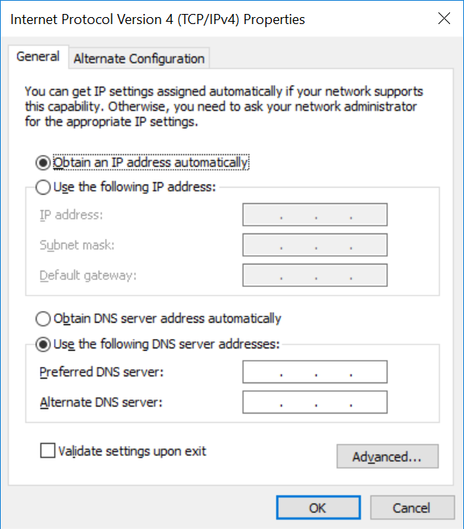

**C. Understand the difference between private IP address and Public IP address**

1. Go to <https://whatismyipaddress.com/> and record down your IP address.

|  |  |
| --- | --- |
| What is my IP address? | 132.147.122.241 |

**D. Ping Loopback Address**

To test whether or not TCP/IP is functioning on the local host, first ping the loopback address 127.0.0.1:

1. [Open a command prompt](https://en.wikiversity.org/wiki/Command_Prompt/Open).
2. Type ping 127.0.0.1 and press Enter.
3. Observe the results. You should see replies indicating success.

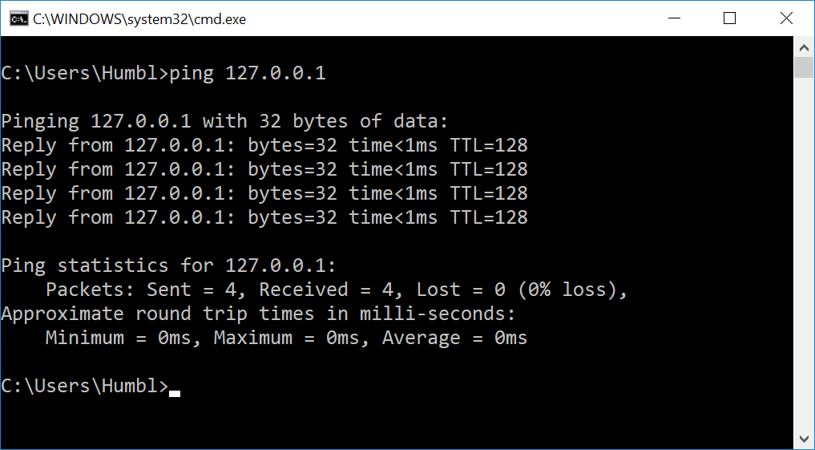

Record down the minimum, maximum and average round trip times in milli-seconds:

|  |  |  |
| --- | --- | --- |
| Min | Max | Average |
| 0ms | 0ms | 0ms |



**E. Ping Localhost**

To test host name cache resolution, ping the name **localhost**. This is an **alias** for the loopback address (127.0.0.1):

1. Type **ping localhost** and press Enter.
2. Observe the results. You should see replies indicating success.

**F. Ping the Host IPv4 Address**

To test the local host IPv4 address:

1. Use [ipconfig](https://en.wikiversity.org/wiki/Ipconfig/Default) to display the host IP address. Note the IPv4 address displayed.

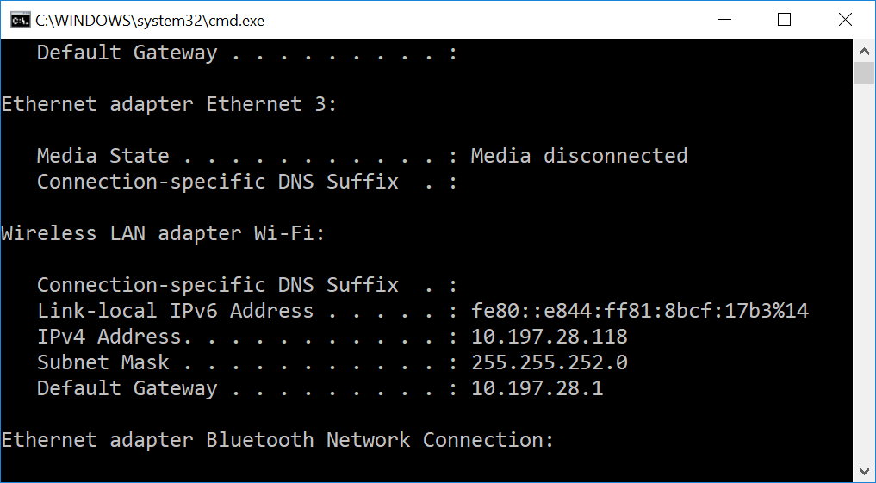

|  |  |
| --- | --- |
| Your IP Address | 192.168.50.241 |

1. Type ping <IPv4 Address> where <IPv4 Address> is the IPv4 address displayed above. For example, if the IPv4 address is 192.168.1.101, you would type ping 192.168.1.101. Then press Enter.
2. Observe the results. You should see replies indicating success.
3. Record down the minimum, maximum and average round trip times in milli-seconds:

|  |  |  |
| --- | --- | --- |
| Min | Max | Average |
| 0ms | 0ms | 0ms |

**G. Ping the Host Name**

To test the local host name:

1. Use [**ipconfig /all**](https://en.wikiversity.org/wiki/Ipconfig/All) to display the host name. Note the **Host Name** displayed.
2. Type**ping <hostname>** where <hostname> is the Host Name IPv4 address displayed above. For example, if the host name was host1, you would type ping host1. Then press Enter.
3. Observe the results. You should see replies indicating success.

**H. Ping the Default Gateway**

To test local network connectivity:

1. Use [**ipconfig**](https://en.wikiversity.org/wiki/Ipconfig/Default) **/all** to display the default gateway address. Note the Default Gateway IP Address displayed.

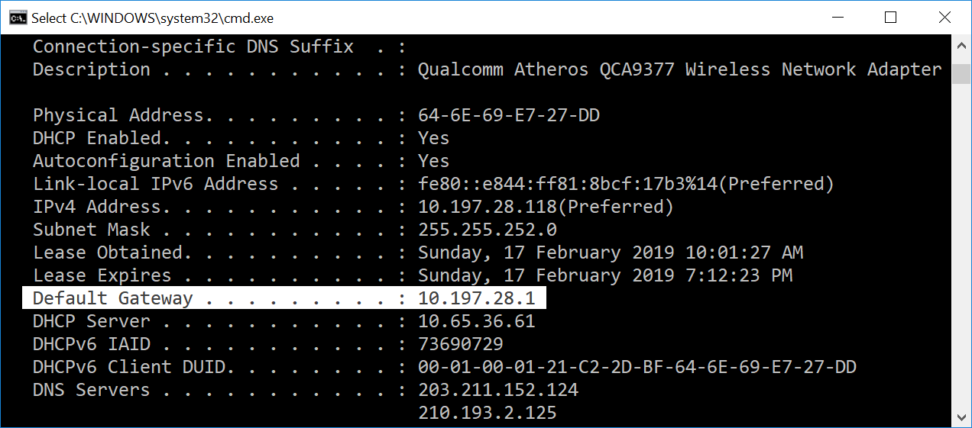

|  |  |
| --- | --- |
| Your Default Gateway IP Address | 192.168.50.1 |
| What is default gateway used for? | The default gateway is used to pass information when the device does not know where the destination is. |

1. Type **ping <*default gateway address*>**where <default gateway address> is the default gateway address displayed above. For example, if the default gateway address is 192.168.1.1, you would type ping 192.168.1.1. Then press Enter.
2. Observe the results. If you see replies indicating success, you have local network connectivity.

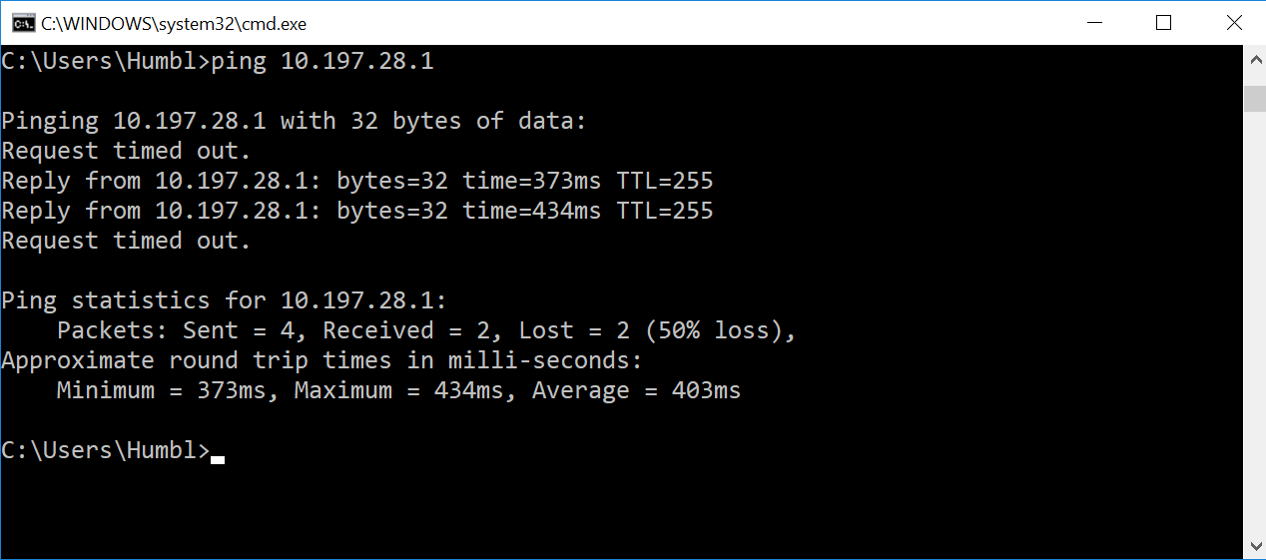

1. Record down the minimum, maximum and average round trip times in milli-seconds:

|  |  |  |
| --- | --- | --- |
| Min | Max | Average |
| 3ms | 15ms | 7ms |



**I. Ping an Internet Host by IPv4 Address**

8.8.8.8 is the IPv4 address of one of Google's public DNS servers. To test Internet connectivity:

1. Type ping 8.8.8.8 and press Enter.
2. Observe the results. If you see replies indicating success, you have Internet connectivity.
3. Record down the minimum, maximum and average round trip times in milli-seconds:

|  |  |  |
| --- | --- | --- |
| Min | Max | Average |
| 4ms | 8ms | 6ms |



**J. Ping an Internet Host by Name**

**google-public-dns-a.google.com** is the host name of one of Google's public DNS servers. To test Internet connectivity with host name resolution:

1. Type ping google-public-dns-a.google.com and press Enter.
2. Observe the results. If you see replies indicating success, you have Internet connectivity and host name resolution.

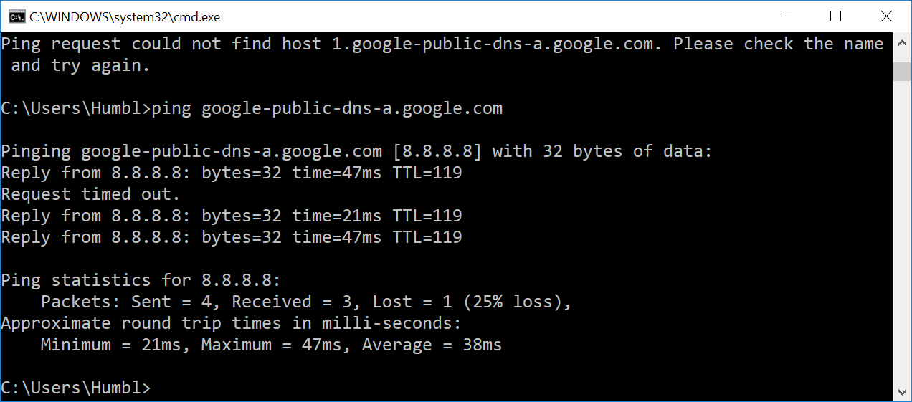

**K. Ping an Internet Host by IPv6 Address**

2001:4860:4860::8888 is the IPv6 address of one of Google's public DNS servers. To test IPv6 Internet connectivity:

1. Type ping 2001:4860:4860::8888 and press Enter.
2. Observe the results. If you see replies indicating success, you have IPv6 Internet connectivity.

**L. Install WireShark**

## Activity 1 - Determine System Type

To determine system type:

1. Use [**msinfo32**](https://en.wikiversity.org/wiki/Msinfo32/System_summary) to display the system type. The system type will either be **X86-based PC** or **X64-based PC**. X86-based PC is a 32-bit system. X64-based PC is a 64-bit system.
2. Close msinfo32.

## Activity 2 - Download Wireshark

To download Wireshark:

1. Open a web browser.
2. Navigate to [**http://www.wireshark.org**](http://www.wireshark.org/).
3. Select **Download Wireshark**.
4. Select the Wireshark Windows Installer matching your system type, either 32-bit or 64-bit as determined in Activity 1. Save the program in the Downloads folder.
5. Close the web browser.

## Activity 3 - Install Wireshark

To install Wireshark:

1. Open Windows Explorer.
2. Select the Downloads folder.
3. Locate the version of Wireshark you downloaded in Activity 2. Double-click on the file to open it.
4. If you see a User Account Control dialog box, select **Yes** to allow the program to make changes to this computer.
5. Select **Next >** to start the Setup Wizard.
6. Review the license agreement. If you agree, select **I Agree** to continue.
7. Select **Next >** to accept the default components.
8. Select the shortcuts you would like to have created. Leave the file extensions selected. Select **Next >** to continue.
9. Select **Next >** to accept the default install location.
10. Select **Install** to begin installation.
11. Select **Next >** to install WinPcap.
12. Select **Next >** to start the Setup Wizard.
13. Review the license agreement. If you agree, select **I Agree** to continue.
14. Select **Install** to begin installation.
15. Select **Finish** to complete the installation of WinPcap.
16. Select **Next >** to continue with the installation of Wireshark.
17. Select **Finish** to complete the installation of Wireshark.

Activity 4 - Capture ping traffic using Wireshark

* 1. Start Wireshark and choose the interface

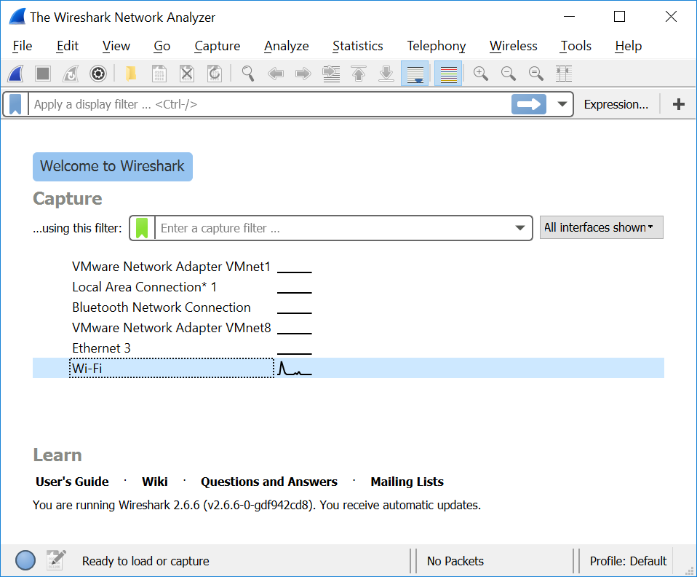

Click the capture button.

* 1. In Command Prompt, Type ping google-public-dns-a.google.com and press Enter.

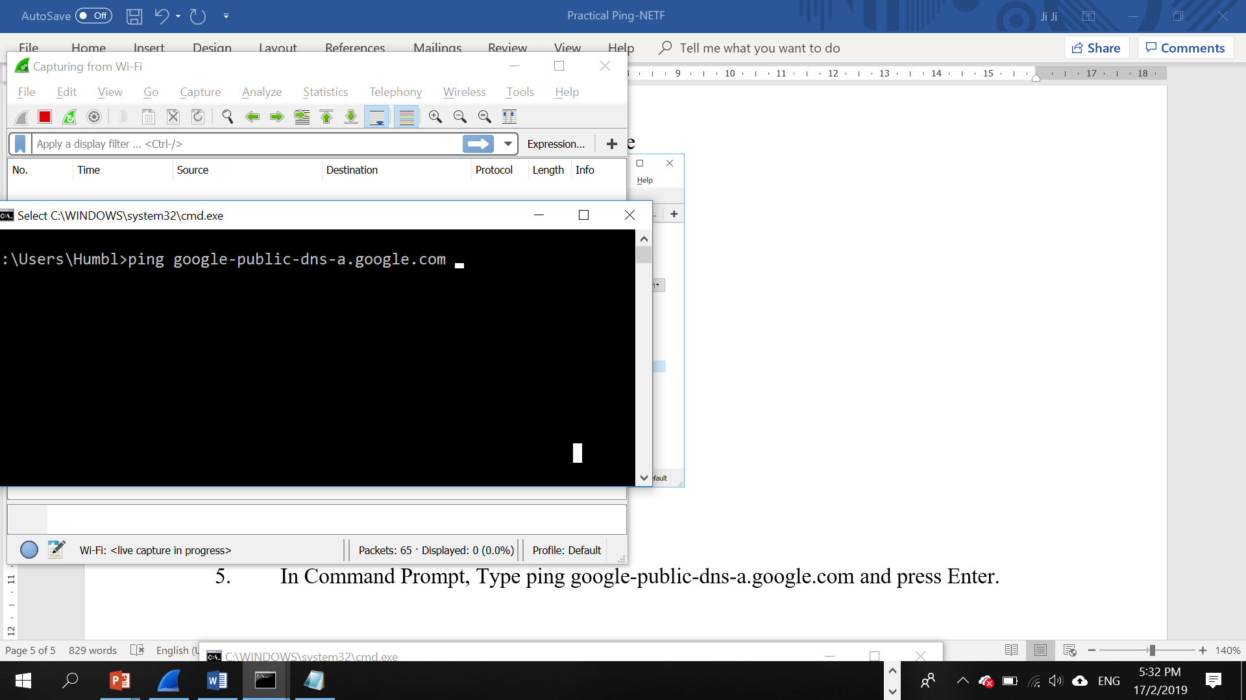

* 1. Observe the ICMP packet, find the size in bytes for the request? Find out the content.
  2. Observe the ICMP packet, find the size in bytes for the the reply? Find out the content.

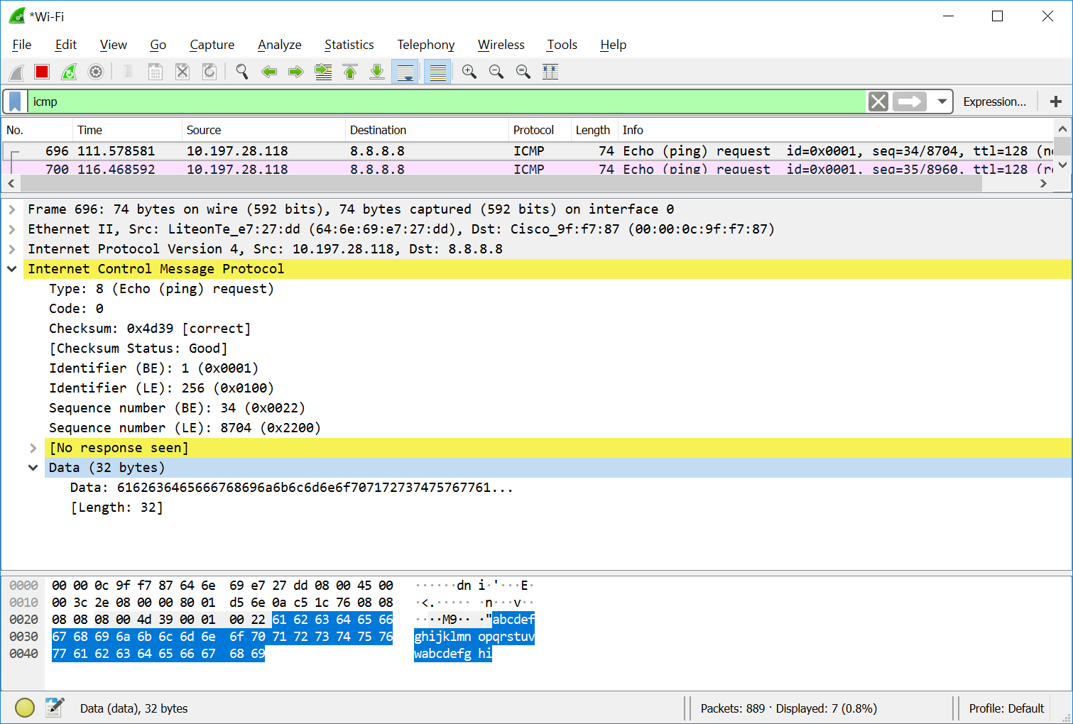

* 1. Record down your observation:

|  |  |  |
| --- | --- | --- |
| ICMP Request | ICMP data length in bytes | 32 bytes |
| Data content in Hex |  |
| Data content in ASCII |  |
| ICMP Response | ICMP data length in bytes | 32 bytes |
| Data content in Hex |  |
| Data content in ASCII |  |

*End of Practical*